Directions: Solve the following systems of equations by graphing.
$y>3x−5$ $y≤−\frac{2}{5}x+1$ $y≥−4x+6$ $y<\frac{1}{3}x−2$

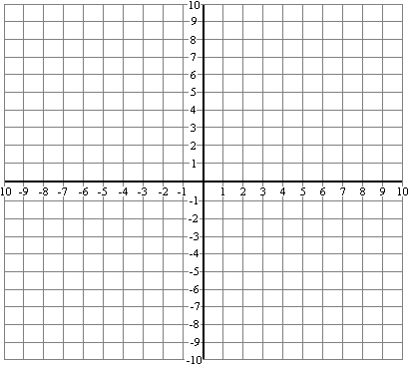

$y−2<−\frac{1}{2}x+1$ $2y>8x−2$ $y+3≤3x−4$ $4y>−3x+8$

